TASK 1 – CUSTOMER BEHAVIOR ANALYSIS
Notebook link (code included):
https://colab.research.google.com/drive/1_VEn4C9CQD-SEMkAtrS9NYVwdpjCp49N#scrollTo=F21uYRqtTKLD
Visualizations:
Bar Graph-
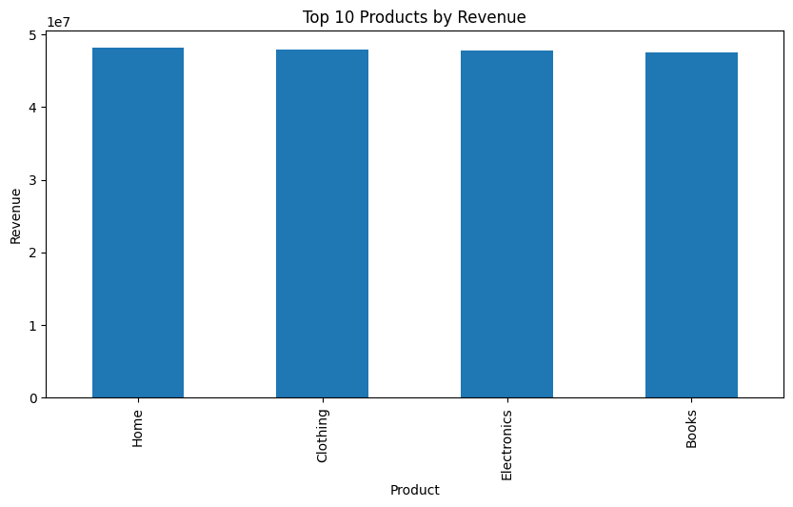
Line Graph-
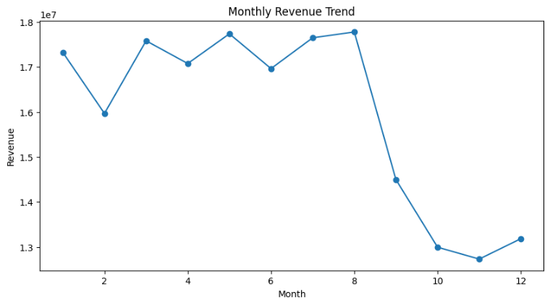
Histogram-
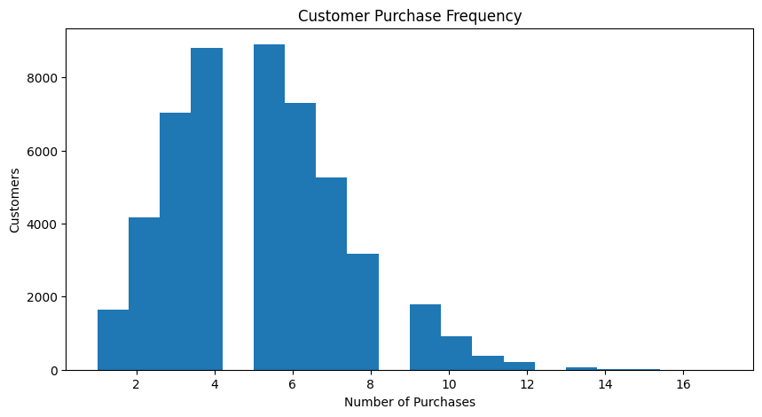

Clustering:
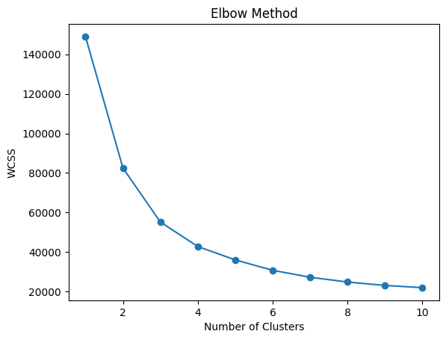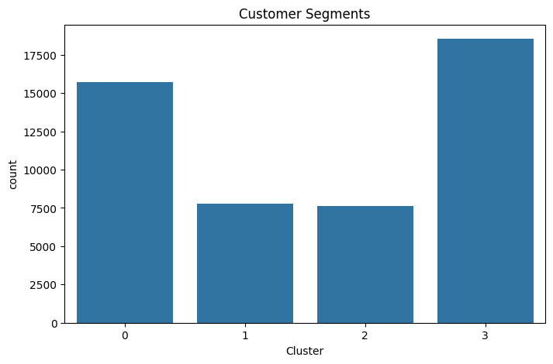
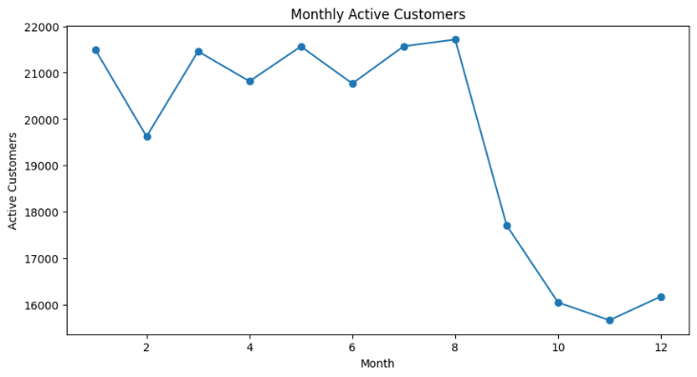
Churn Risks:
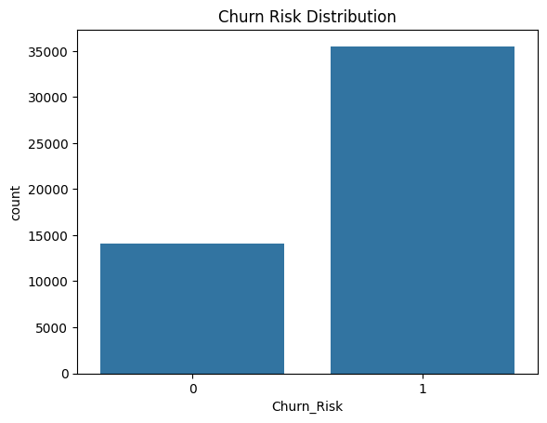
Short Summary:
1. Data Cleaning and Feature Engineering
Data cleaning is the process of preparing raw data for analysis by removing duplicates, handling missing values, correcting data types, and ensuring consistency in the dataset. This improves the accuracy and reliability of the analysis.
Feature engineering involves creating new useful variables from existing data to improve analysis and customer understanding. Examples include:
- Revenue = Quantity × Price
- Extracting month and year from transaction dates
- Calculating purchase frequency
Basic summary statistics such as mean, median, mode, missing values, and data types are analyzed to understand the dataset structure and distribution.
Visualizations like bar charts, line charts, and histograms are used to summarize customer transactions, product performance, and sales trends.
2. Customer Segmentation (RFM / Clustering)
Customer segmentation divides customers into groups based on purchasing behavior.
RFM analysis is a commonly used segmentation technique:
- Recency → How recently a customer purchased
- Frequency → How often a customer purchases
- Monetary → How much a customer spends
Clustering techniques such as K-Means are applied to group customers with similar behaviors into segments like:
- Loyal customers
- High-value customers
- New customers
- At-risk customers
Segment profiling helps businesses understand customer characteristics and create targeted marketing strategies.
3. Purchase Patterns and Retention Trends
Purchase pattern analysis identifies customer buying behavior, popular products, seasonal trends, and revenue fluctuations over time.
Retention trend analysis measures how consistently customers continue purchasing from the business. Metrics such as active customers, repeat purchases, and recency help identify customer loyalty and churn risk.
Visualizations are used to analyze:
- Monthly sales trends
- Product demand
- Customer activity
- Churn distribution
These insights help businesses improve customer engagement, retention, and profitability.

